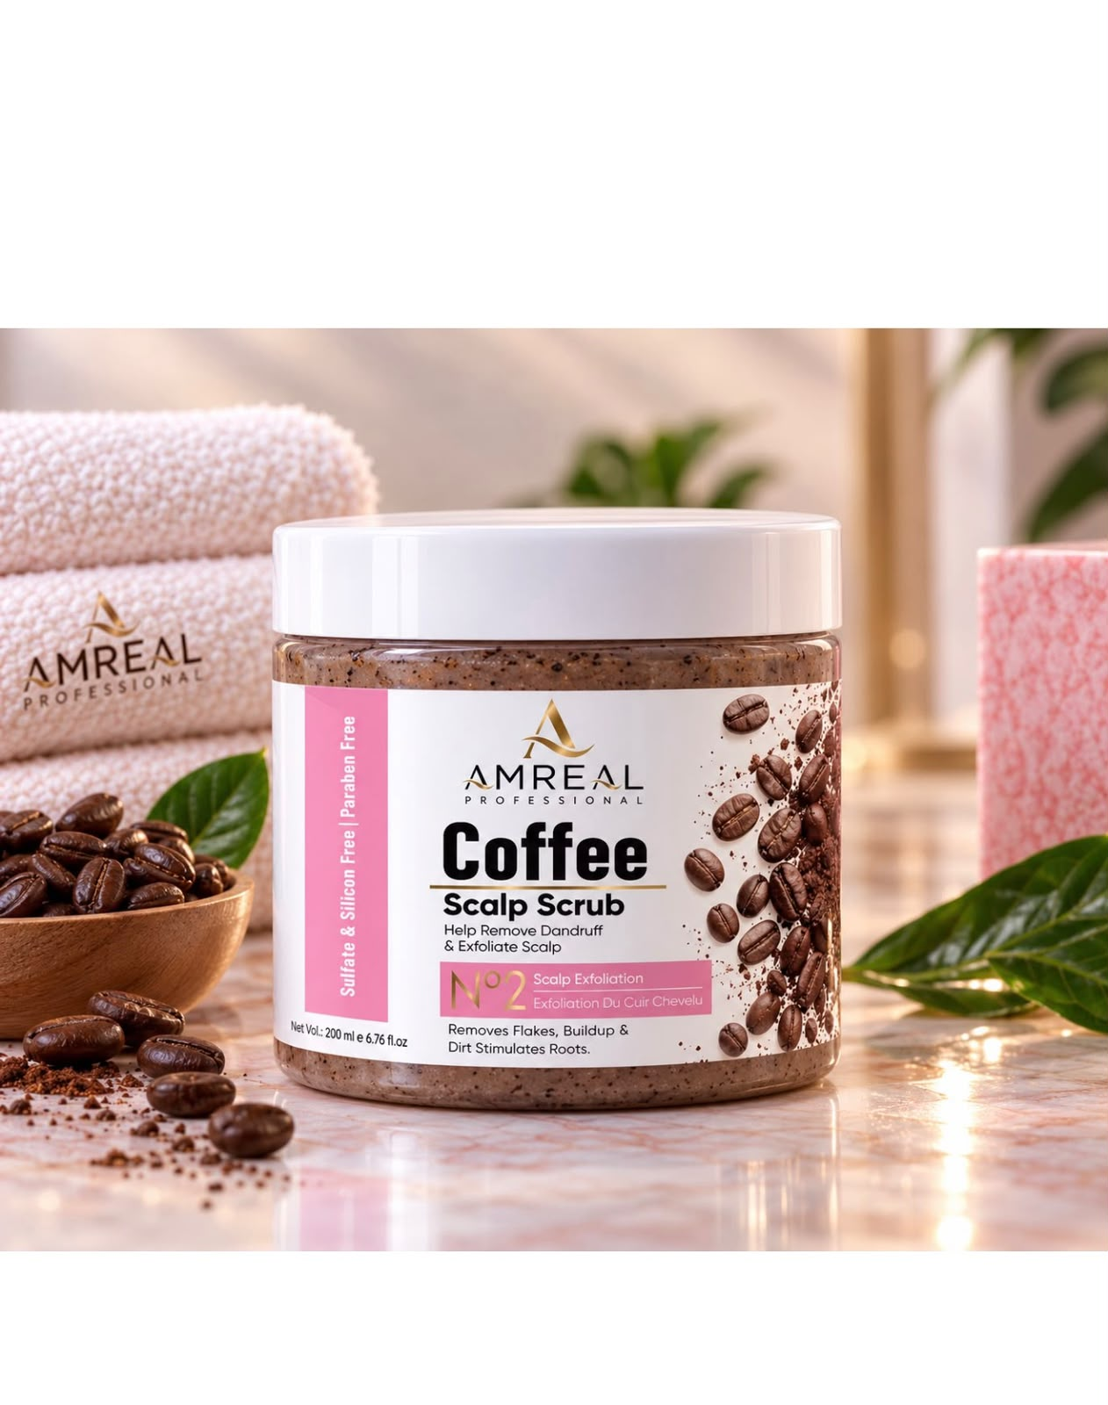
AMREAL COFFEE SCALP SCRUB — NO.2

PROFESSIONAL SCALP EXFOLIATION

A refined scalp-exfoliating treatment designed to lift surface flakes, excess buildup and impurities, leaving the scalp feeling refreshed, clean and balanced.

KEY INGREDIENTS

01 — COFFEE EXTRACT
Scalp Revitalisation & Antioxidant Care

02 — SALICYLIC ACID
Helps Loosen Flakes & Surface Buildup

03 — LACTIC ACID
Gentle Exfoliation & Smoother Scalp Feel

04 — D-PANTHENOL
Conditioning & Moisture Support

05 — VITAMIN E
Antioxidant & Nourishing Care

KEY BENEFITS

* Helps remove visible scalp flakes and buildup
* Gently exfoliates the scalp surface
* Helps lift excess residue and impurities
* Leaves the scalp feeling fresh and thoroughly cleansed

CONCERNS

* Visible Flakes
* Scalp Buildup
* Product Residue
* Oily/Heavy Scalp Feel
* Dull, Congested Scalp
* Uneven Scalp Cleansing
* Scalp Requiring Exfoliation

SUITABLE FOR

Buildup-Prone • Flaky • Oily • Congested • Dull • Normal Scalp

RESET THE SCALP. REFRESH THE ROOTS

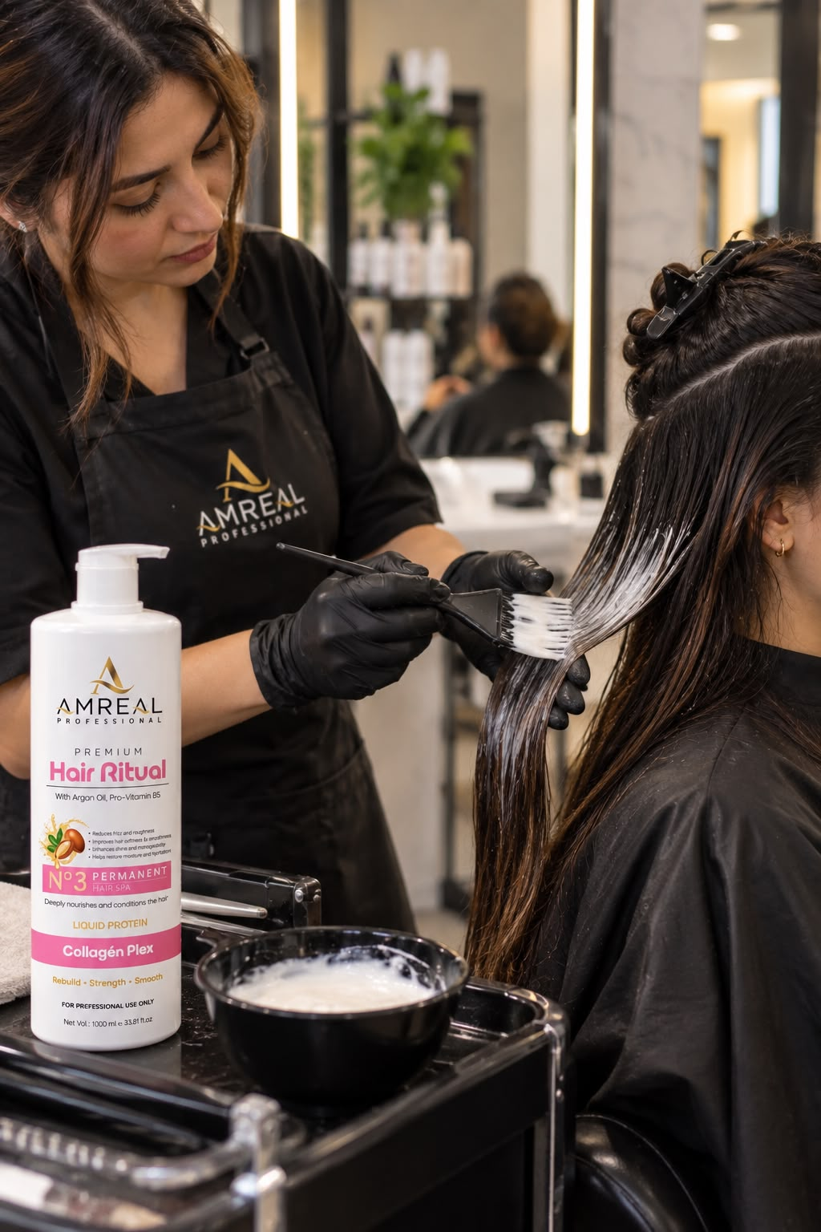

AMREAL NANOPLASTIA — PROFESSIONAL HAIR TREATMENT

CONCERNS

* Frizz & Flyaways
* Coarse, Unmanageable Hair
* Dryness & Roughness
Difficult-to-Manage Hair
* Uneven Hair Texture

KEY BENEFITS

* Helps create a smoother, more polished hair surface
* Helps reduce the appearance of frizz and flyaways

Creates a sleek, more controlled finish
* Helps maintain smoother-looking hair for an extended period

KEY INGREDIENTS

01 — HYDROLYZED PROTEINS
Fibre Conditioning & Strength Support

02 — CYSTEINE & AMINO ACIDS
Hair Fibre Care & Smoothness

03 — GLYCOLIC ACID
Helps Support Smoother, More Manageable Hair

04 — COCONUT OIL
Nourishment & Shine

05 — ARGAN OIL
Softness, Conditioning & Gloss

06 — PRO-VITAMIN B5
Moisture & Conditioning Support

SUITABLE FOR

Frizzy • Coarse • Dry • Rough • Unmanageable • Dull Hair

